Wireframe: Spam Ham Detection

Wireframe Documentation

|  |  |  |  |
| --- | --- | --- | --- |
| Date Issued | Version | Description | Author |
| 26-11-2022 | 1 | Wireframe-V1.0 | Mohit Bhadauria |
|  |  |  |  |

User Interface for Single User Input: Very simple UI for user will be there, Where user only need to feed their text message and they need to click Predict Button.

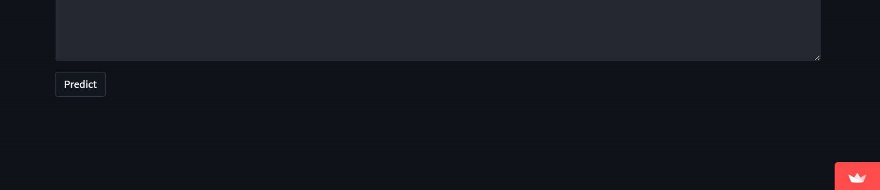

In provided text area users need to feed their message.

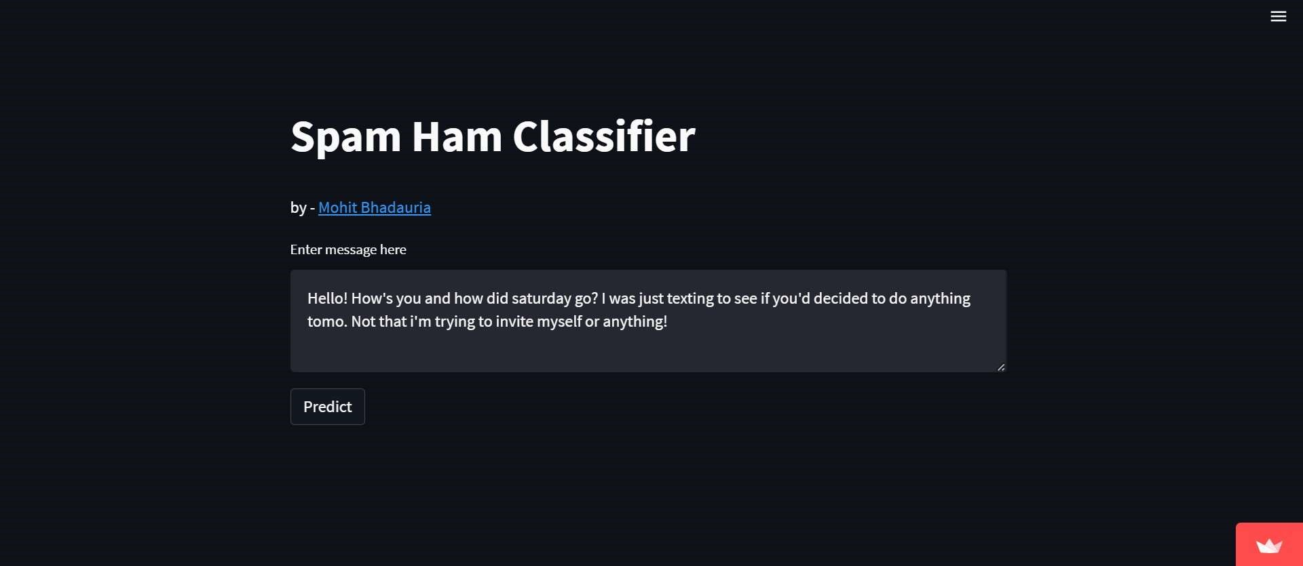

After feeding text message user need to click Predict Button.

